SIT302 Project

User Guide

Online Book Store



GROUP 6

YOUSEF NAIF A ALHARBI

NOHA JAMALI A SALEM

FAISAL ABDULLAH M BIN GHIMLAS

AHMED AL SHAMISI

ABDULLAH ALDOKHIIL

AVIRAJ KAMBOJ

JALAB JALBANI

# Table of Contents

Table of Contents 2

1.0 Introduction 3

1.1 Document Purpose 3

2.0 User Front-end manual 4

2.1 Home page 4

2.2 “About Us” Page 5

2.3 “Books” Page 5

2.4 “User Registration” Page 6

2.5 “My Account” Page 7

2.6 “Update Profile” Page 8

2.7 “View Category Products” Page 8

2.8 “View Category Products” Page 9

2.9 Add products to shopping cart 9

2.10 Shopping Cart page 9

2.11 Shopping Cart page 10

2.12 Order History page 11

3.0 Bibliography 12

# 1.0 Introduction

## 1.1 Document Purpose

The purpose of this document is to provide a comprehensive user guide that will assist the front-end users of the system in use of the system. There are two key parts to the system:

| **User Side** | **Administrator Side** |
| --- | --- |
| Front-end | This is the front-end of the system which will be accessed by the everyday users. It includes features to:   * Search products * Add products to shopping cart * View static information * Checkout products and pay for them * Registration, Login and Password Retrieval * View past order history |

# 2.0 User Front-end manual

## 2.1 Home page

The home page of the system below describes the general structure of all pages in the system. For example, the below home page have these components:

1. **Header**: The header of the page contains the logo and a large banner.
2. **Top navigation**: Top navigation is the main navigation for the system. It contains the links for “Home”, “About Us”, ”Books”, “My Account”, “Contact”, “Register”
3. **Featured Books**: This is the content area of the page that displays the information that is relevant to the page that is being displayed.
4. **My Cart**: this section will display whether there are any items in the cart and the total of the cart.
5. **Categories**: This section allows the user to quickly browse to any section of the website.

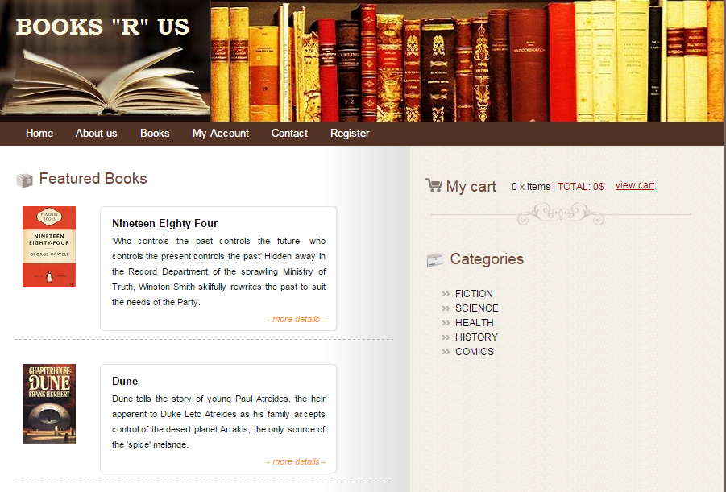

Figure 1

## 2.2 “About Us” Page

This page displays information about the organization.

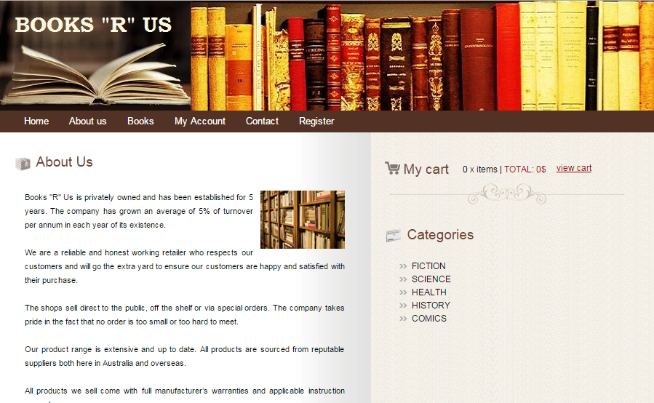

Figure 2

## 2.3 “Books” Page

This page displays the products that are available for purchase. The products that are 0 stock are not displayed on the front-end. The user can go to “More details” to see details and buy products.

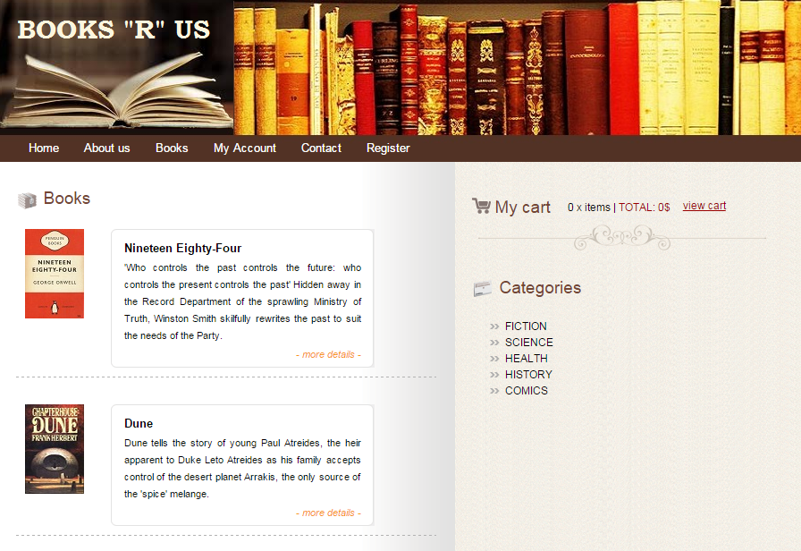

Figure 3

## 2.4 “User Registration” Page

This page allows the user to register for a new account. The mandatory fields are marked with a *. The mandatory fields are last name, password, address line 1, address line 2, suburb, state and postcode.

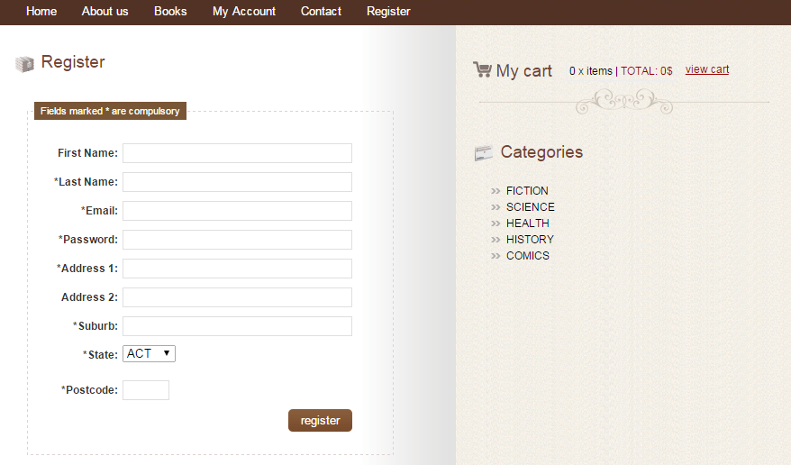

Figure 4

Once the user has entered all required fields and submitted the form, the user is registered successfully.

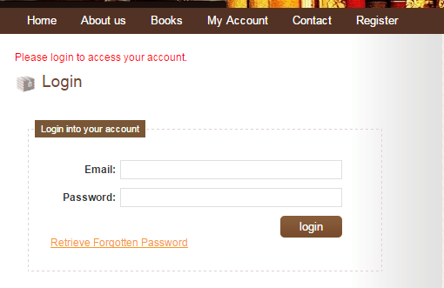

Figure 5

## 2.5 “My Account” Page

The user can click on the “My Account” page to login to the account.

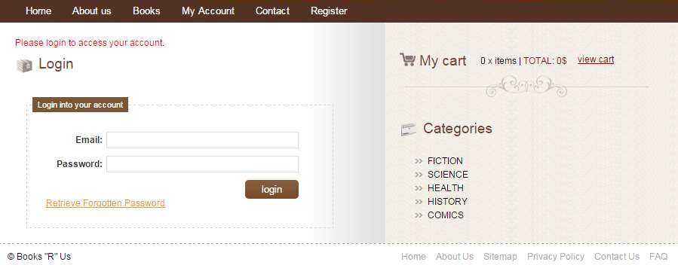

Figure 6

Once the user has entered the user id and password successfully, the user is taken to the My account page for successful login.

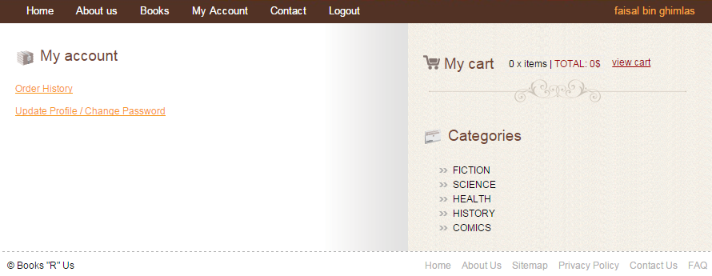

Figure 7

## 2.6 “Update Profile” Page

The update profile page will display the current information. The user can change the information and select update.

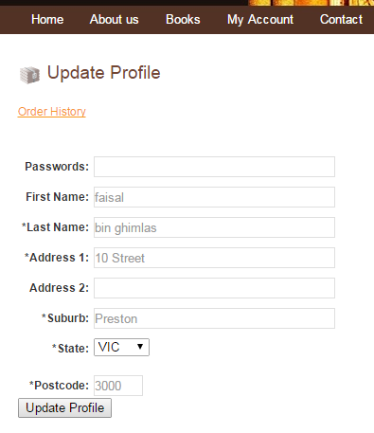

Figure 8

## 2.7 “View Category Products” Page

The user can select a category from the right hand side which will display all of the products from that category only.

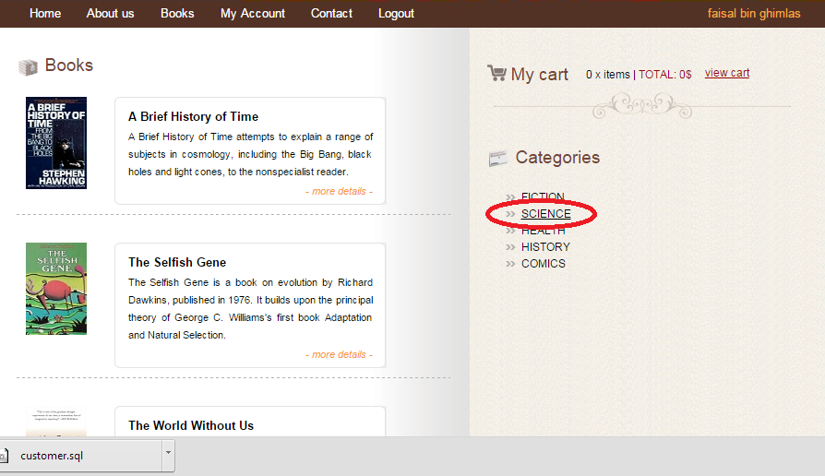

Figure 9

## 2.8 “View Category Products” Page

The user can select a category from the right hand side which will display all of the products from that category only.



Figure 10

## 2.9 Add products to shopping cart

The user can select the “Order Now” option to add products into the shopping cart.

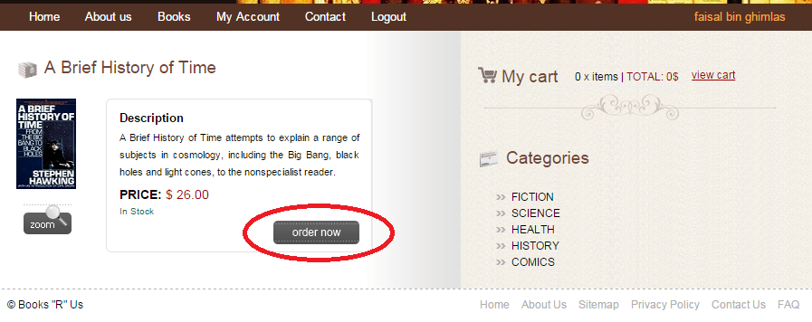

Figure 11

## 2.10 Shopping Cart page

The user can select the “Order Now” option to add products into the shopping cart.

The shopping cart has following features:

1. “Continue” link will take the user to the products page that will allow the user to add more products into the shopping cart.
2. The “Clear Cart” will empty the shopping cart.
3. The “Remove” link will delete the item from the shopping cart (irrespective of the quantity that has been entered)
4. The user can change the quantity and click on “Update” to update the quantity of products to be purchased.
5. The “Checkout” link will take the user to a checkout page that will allow the user to enter payment information and confirm.

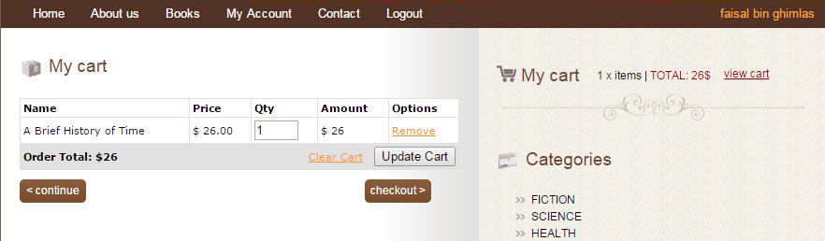

Figure 12

## 2.11 Shopping Cart page

The user can select “Calculate Delivery” to calculate how much the overall delivery will cost.

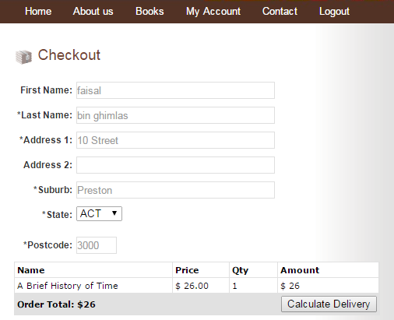

Figure 13

The next page displays the delivery cost and the user can enter special instructions for delivery.

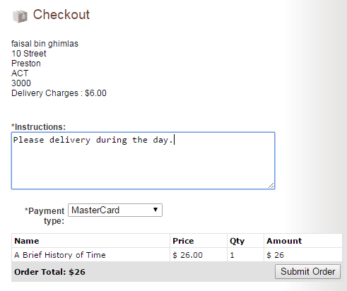

Figure 14

Now, the user can click on “Submit Order” to submit the order. This is the final step in the order. The user is now taken to the order history page as the confirmation that the order has been submitted.

## 2.12 Order History page

The order history page allows the user to see all of the past orders.

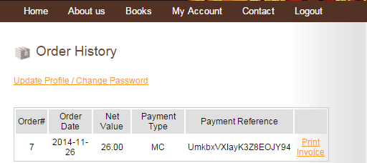

Figure 15

Now, the user can select “Print Invoice” to print an invoice. The user can then select “Print Invoice” to print the invoice

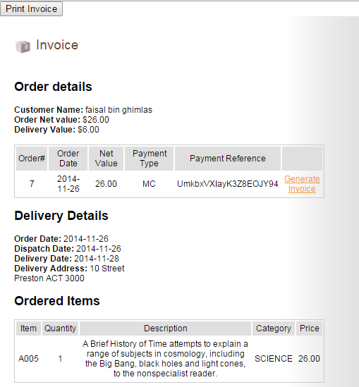

Figure 16

# 3.0 Bibliography

Paessler User Manual Template, Paessler Website, viewed on 25 January 2015 at <http://download-cdn.paessler.com/download/photomeistermanual.pdf>